**DATABASE 2 ASSIGNMENT**



**Group Object:MyPhone Mobile Phone Service**

**Group Number:6**

**Group Members:**

**Student Name: Student Number:**

Minhui Chen D17125347

Yuwei Chen D16123951

Jianyu he D17124591

**Project introduce:**

**For this assignment, I with my group mates are design a database for the “MyPhone Mobile Phone Service” company to store staff details, customer details, phone information, server contract, retail outlet information, and customer usage.**

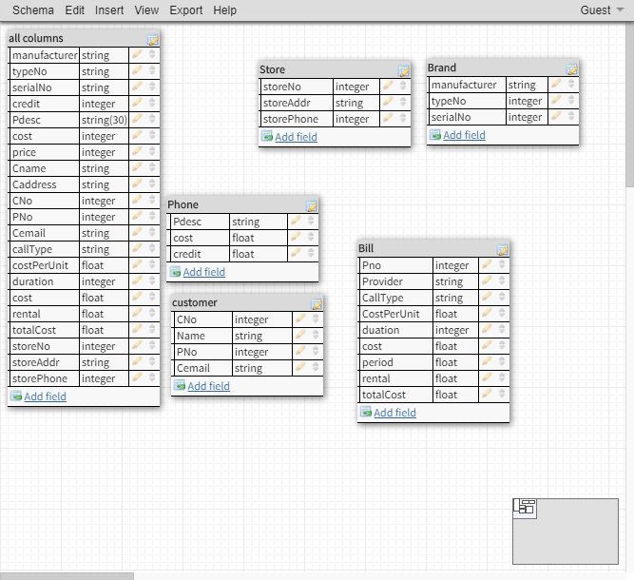

This is my group first simple diagram to help design ERD. We list all columns and list some table we may use. And do some column constraint, set value. This is help us to define what relationship between tables. How many tables need, why need? What column will be in which tables.

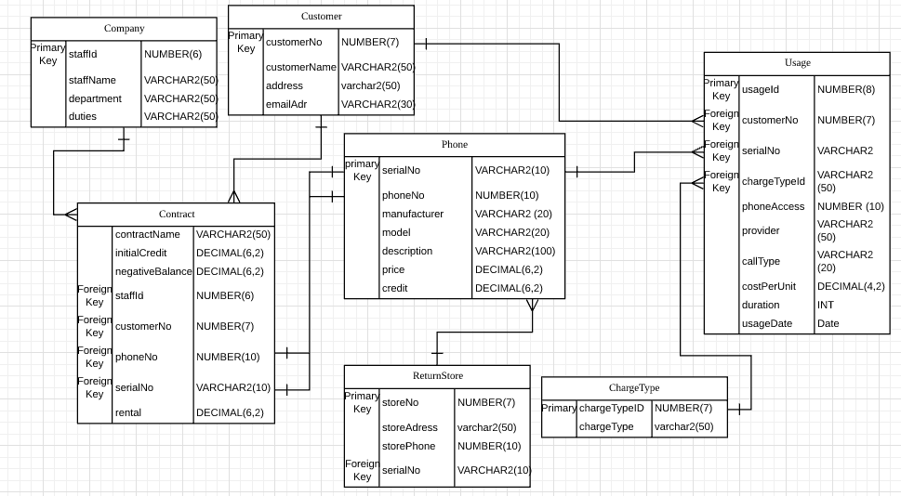

This is the final design for ERD. It has 6 tables to store different information for company. Company table is used to store staff information. e g. Customer table is used to store customer details. The customer tables to store customer details etc.

Relationship:

Company -> Contract: one to many, company may have different contracts with different customer.

Customer -> Contract: one to many, one customer may have many contracts.

Phone -> Contract: one to one, each contract only sale one phone.

Customer -> Usage: one to many, customer not only use phone once, so customer will have many usage records to store in Usage table.

Phone -> Usage: one to many, one phone can have many usage records, etc.

Phone -> ReturnStore: many to one, one shop will allow to let customer return many phones in one time.

ChargeType -> Usage: one to many. one chargeType may will have use for many usage records.